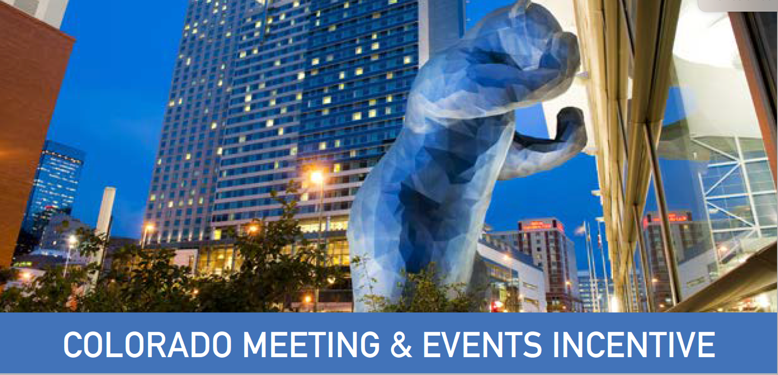

Official Program Website: https://www.destinationcolorado.com/coloradomeetingincentive/
All resources needed to apply for the program are maintained on this site. It is important to direct inquiries to this central website for program and application information as updates and modifications to program materials and guidelines will be managed here.

Organic Social Copy
It pays to bring your next meeting or event to Colorado
The Meeting and Events Incentive Program provides pre-approved applicants with a 10% rebate up to $100,000 against eligible costs of hosting meetings and events between now and June 30, 2024. Funding is allocated on a first come basis so find out now if your event is eligible and how to apply.

Newsletter Copy:
Thousands of Reasons to Meet in Colorado
You know Colorado for its central location, award-winning amenities, bucket-list adventures and scenic mountain communities. Add one more impressive reason to book that business sooner than later.

Colorado’s Meeting & Events Incentive Program provides pre-approved applicants with a 10% rebate up to $100,000 against the eligible costs of hosting meetings and events that take place in Colorado between now and June 30, 2024.
Funding is allocated on a first come basis so find out now if your event is eligible and how to apply.

Eblast Copy:
Subject line: Receive up to $100,000 rebate on your Colorado meeting or event

Headline: It pays to bring your next meeting or event to Colorado

There are countless reasons to hold your meeting or event in Colorado -- our central location, award-winning convention and meeting facilities, bucket-list adventures, wide open spaces, scenic mountain communities and so much more. It's no wonder our iconic destination is at the top of the list for in-the-know planners.
And if that’s not enough, you can add one more impressive reason to book that business sooner than later: Colorado’s Meeting & Events Incentive Program.
Available until June 30, 2024 or until funds run out, the $10 million Meeting and Events Incentive Program provides pre-approved applicants with a 10% rebate up to $100,000 against the eligible costs of hosting meetings and events in Colorado. Funding is allocated on a first come basis so find out now if your event is eligible and how to apply.

Primary Image:

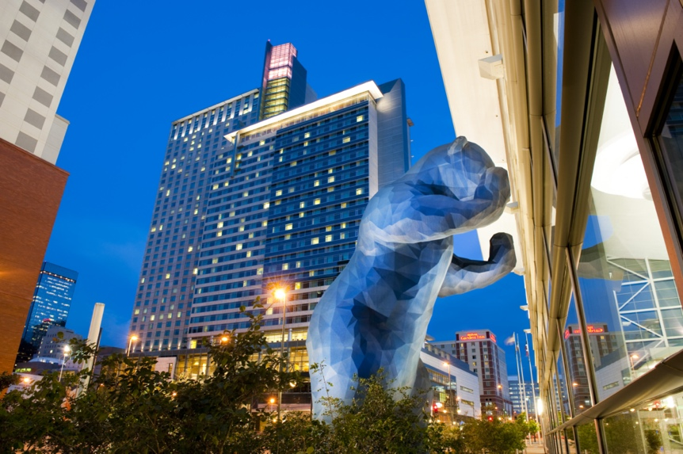

Additional Images:

Logos:
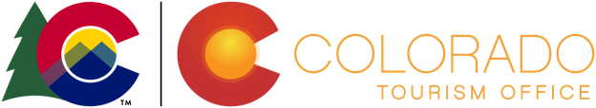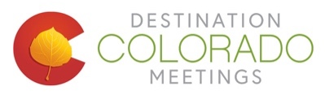

Blue banner color:
CMYK RGB
C:78 R:66
M:50 G:116
Y:0 B:185
K:0.

